Student Record System SRS - High Level Business Process Activity Diagram

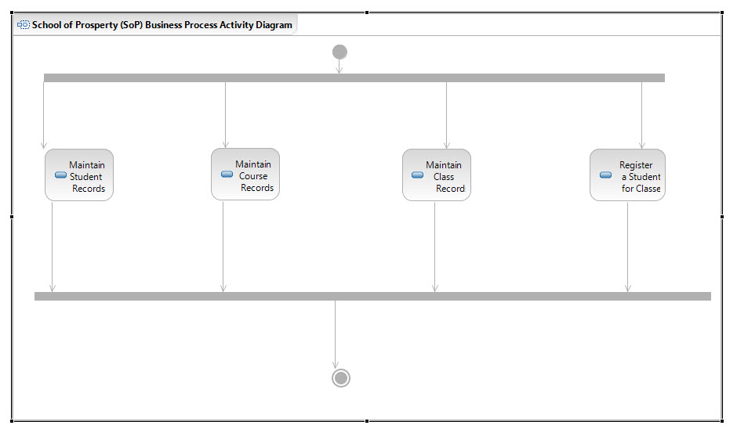

This activity diagram is based on the SRS Requirements Definition document.

It models the high-level business processes of the SRS system. There are 4 parallel activities that needed to be addressed:

1. Maintain Student Records  
   Maintains information about students in the school
2. Maintain Course Records  
   Maintains information about courses offered by the school
3. Maintain Class Records  
   Maintains information about classes (online or face-to-face) offered of various courses at the school
4. Register a Student for Classes  
   This activity registers a student a student for a set of classes (online and/or face-to-face)